**Lab Project**

**Voice Over IP (VoIP) Phone Server**

**Calls Database**

Alexander R. Ramsey

DBST 651, Fall 2017

Submitted To

Graduate School

University of Maryland University College

November 26, 2017

**Statement of Work (SOW)**

**Overview:**

I will create a database to track incoming call history for a VoIP (Voice over internet protocol) phone server powered by FreePBX, an open source phone server software.

**Purpose and Objective:**

The database will allow a phone server to connect and create records pertaining to incoming/outgoing calls including date, time, phone number, and call duration. This will provide the foundation for a separate application to connect and manage these records so that an office employee can easily view past call history. The information stored in the database will be available for other purposes including linking with a CRM (Customer Relationship Management) solution which will allow office employees to view client data as a call is commenced, based upon a link between phone number and stored client data.

**Diagram Tool:**

Oracle SQL Data Modeler

**Database:**

Oracle Server Hosted on UMUC Amazon DaaS

**Hardware and Software:**

Microsoft Windows Virtual Machine, Oracle SQL Server

**DDL and DML:**

Structured Query Language will be used for the DDL and DML. SQL schema definition will be generated via an ER diagram using Oracle SQL Data Modeler. DML scripts will utilize INSERT queries to generate rows of phone data into the database.

**Application Requirements**

**Stakeholders:**

1. **Client** - Makes calls to the business phone server. Receives calls from the business phone server via the Customer Service Representative.
2. **Customer Service Representative (Office Employee/CSR)** - Makes calls to the client using the business phone server. Receives calls from the client from the business phone server. Tracks client call activity via the phone server database.

**Requirements:**

1. Incoming calls from the Client to the CSR should be recorded in the database with the following information: Start Datetime (at beginning of call), End Datetime (at time of call end), Duration of Call (at time of call end), Origin Phone Number (at beginning of call), Destination Phone Number (at beginning of call), Call Action Code (as they occur).
2. Outbound calls to the Client from the CSR should be recorded in the database with the following information: Start Datetime (at beginning of call), End Datetime (at time of call end), Duration of Call (at time of call end), Origin Phone Number (at beginning of call), Destination Phone Number (at beginning of call), Call Action Code records (as they occur).
3. An associated Client Relationship Management (CRM) application should be able to connect and utilize Incoming Call and Client data via a Join relationship query to determine Client First Name and Client Last Name upon call initiation.
   1. Incoming calls will utilize the Origin Phone Number to compare with Client Records to determine if a client is known or unknown.
   2. Outbound calls will utilize the Destination Phone Number to compare with Client Records to determine if a client is known or unknown as well as to record a record which the CRM could use to track client contact occurrences.

**Database Definition**

**Data Dictionary:**

|  |  |  |  |  |
| --- | --- | --- | --- | --- |
| **Table** | | | | |
| **P/F** | **Field Name** | **Data Type** | **Field Size** | **Notes/Constraints** |
| CALL | | | | |
| PK | call_id | UID | 10 | Auto Increment (AI) |
|  | call_datetime_start | Timestamp | 10 | With Time Zone |
|  | call_datetime_end | Timestamp | 10 | With Time Zone |
|  | call_duration_time | Varchar | 4 | Simple Time in Length |
|  | call_origin_phone_number | Varchar | 10 | Originating Phone |
|  | call_destination_phone_number | Varchar | 10 | Final destination Phone |
| CALL_DETAIL | | | | |
| PK | call_detail_id | UID | 10 | AI Call Detail Primary Key |
|  | call_detail_description | Varchar | 100 | CSR Generated Description of Call |
|  | call_channel | Varchar | 10 | System generated info |
| FK | call_id | UID | 10 | call_id FK |
| FK | call_action_code | UID | 10 | call_action_code FK |
| FK | call_csr_id | UID | 10 | csr_id PK |
| FK | call_client_id | UID | 10 | client_id PK |
| CALL_ACTION_CODE | | | | |
| PK | call_action_code | UID | 10 | AI NN |
|  | call_action_code_name | Varchar | 10 |  |
|  | call_action_code_type | Varchar | 10 |  |
|  | call_action_code_description | Varchar | 100 |  |
|  | call_action_code_priority | Integer | 10 |  |
| CLIENT | | | | |
| PK | client_id | UID | 10 | AI |
|  | client_first_name | Varchar | 20 |  |
|  | client_last_name | Varchar | 20 |  |
|  | client_phone_number_mobile | Varchar | 10 |  |
|  | client_phone_number_work | Varchar | 10 |  |
| CSR (Customer Service Representative) | | | | |
| PK | csr_id | UID | 10 | AI |
|  | csr_first_name | Varchar | 20 |  |
|  | csr_last_name | Varchar | 20 |  |
|  | csr_bio | Varchar | 100 |  |
|  | csr_level | Integer | 10 |  |

**ERD (Entity Relationship Diagram)**

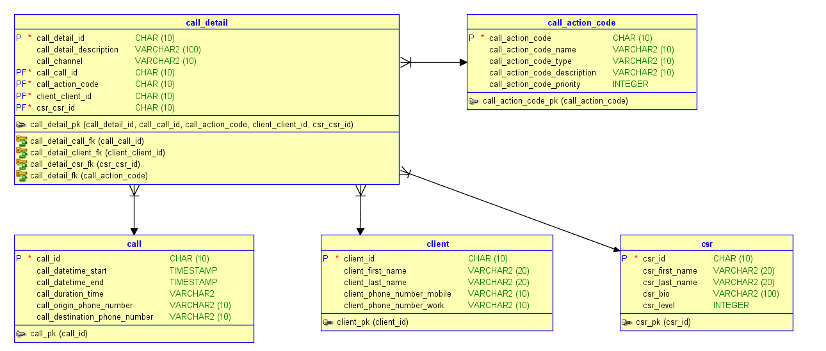

**Data Definition Language (DDL)**

/*

Drop Statements

CASCADE CONSTRAINTS drops references between tables.

*/

DROP VIEW CALLS CASCADE CONSTRAINTS ;

DROP VIEW CSR CASCADE CONSTRAINTS ;

DROP TABLE call CASCADE CONSTRAINTS;

DROP TABLE call_action_code CASCADE CONSTRAINTS;

DROP TABLE call_detail CASCADE CONSTRAINTS;

DROP TABLE client CASCADE CONSTRAINTS;

DROP TABLE csr CASCADE CONSTRAINTS;

DROP SEQUENCE call_id;

DROP SEQUENCE client_id;

DROP SEQUENCE csr_id;

DROP SEQUENCE call_detail_id;

DROP SEQUENCE call_action_code;

/*

I spent a lot of time trying on my own to get the Triggers to work,

they have been commented out in the script so that this script can work properly.

DROP TRIGGER TRIGGER1;

DROP TRIGGER TRIGGER2;

*/

/*

Create Tables call, call_action_code, call_detail, client, & csr

Alter tables to add constraints including primary and foreign key relationships.

*/

CREATE TABLE call (

call_id CHAR(10) NOT NULL,

call_datetime_start TIMESTAMP,

call_datetime_end TIMESTAMP,

call_duration_time VARCHAR2(10),

call_origin_phone_number VARCHAR2(10),

call_destination_phone_number VARCHAR2(10) );

ALTER TABLE call ADD CONSTRAINT call_pk PRIMARY KEY ( call_id );

CREATE TABLE call_action_code (

call_action_code CHAR(10) NOT NULL,

call_action_code_name VARCHAR2(10),

call_action_code_type VARCHAR2(10),

call_action_code_description VARCHAR2(10),

call_action_code_priority INTEGER );

ALTER TABLE call_action_code ADD CONSTRAINT call_action_code_pk PRIMARY KEY ( call_action_code );

CREATE TABLE call_detail (

call_detail_id CHAR(10) NOT NULL,

call_detail_description VARCHAR2(100),

call_channel VARCHAR2(10),

call_call_id CHAR(10) NOT NULL,

call_action_code CHAR(10) NOT NULL,

client_client_id CHAR(10) NOT NULL,

csr_csr_id CHAR(10) NOT NULL );

ALTER TABLE call_detail

ADD CONSTRAINT call_detail_pk PRIMARY KEY ( call_detail_id,

call_call_id,

call_action_code,

client_client_id,

csr_csr_id );

CREATE TABLE client (

client_id CHAR(10) NOT NULL,

client_first_name VARCHAR2(20),

client_last_name VARCHAR2(20),

client_phone_number_mobile VARCHAR2(10),

client_phone_number_work VARCHAR2(10) );

ALTER TABLE client ADD CONSTRAINT client_pk PRIMARY KEY ( client_id );

CREATE TABLE csr (

csr_id CHAR(10) NOT NULL,

csr_first_name VARCHAR2(20),

csr_last_name VARCHAR2(20),

csr_bio VARCHAR2(100),

csr_level INTEGER);

ALTER TABLE csr ADD CONSTRAINT csr_pk PRIMARY KEY ( csr_id );

ALTER TABLE call_detail

ADD CONSTRAINT call_detail_fk FOREIGN KEY ( call_action_code )

REFERENCES call_action_code ( call_action_code );

ALTER TABLE call_detail

ADD CONSTRAINT call_detail_call_fk FOREIGN KEY ( call_call_id )

REFERENCES call ( call_id );

ALTER TABLE call_detail

ADD CONSTRAINT call_detail_client_fk FOREIGN KEY ( client_client_id )

REFERENCES client ( client_id );

ALTER TABLE call_detail

ADD CONSTRAINT call_detail_csr_fk FOREIGN KEY ( csr_csr_id )

REFERENCES csr ( csr_id );

Table CALL created.

Table CALL altered.

Table CALL_ACTION_CODE created.

Table CALL_ACTION_CODE altered.

Table CALL_DETAIL created.

Table CALL_DETAIL altered.

Table CLIENT created.

Table CLIENT altered.

Table CSR created.

Table CSR altered.

Table CALL_DETAIL altered.

Table CALL_DETAIL altered.

Table CALL_DETAIL altered.

Table CALL_DETAIL altered.

/*

Create Views “Calls” and “CSR”:

“Calls” View displays recent call activity for an I.T. consultant who deploys the phone server.

“CSR” View displays client information with dates and times of phone calls for a customer service representative log/dashboard.

*/

CREATE OR REPLACE VIEW CALLS AS

SELECT

call.call_datetime_start,

call.call_datetime_end,

call.call_duration_time,

call.call_destination_phone_number,

call.call_origin_phone_number

FROM

call ;

CREATE OR REPLACE VIEW CSRS AS

SELECT

client.client_first_name,

client.client_last_name,

client.client_phone_number_mobile,

client.client_phone_number_work,

call.call_datetime_start,

call.call_datetime_end,

call.call_duration_time,

call.call_origin_phone_number,

call.call_destination_phone_number,

FROM

call,

client ;

View CALLS created.

View CLIENTS created.

/*

Create Sequences

*/

CREATE SEQUENCE call_id

START WITH 1

INCREMENT BY 1

NOORDER ;

CREATE SEQUENCE client_id

START WITH 10

INCREMENT BY 1 ;

CREATE SEQUENCE csr_id

START WITH 1

INCREMENT BY 1 ;

CREATE SEQUENCE call_detail_id

START WITH 1

INCREMENT BY 1 ;

Sequence CALL_ID created.

Sequence CLIENT_ID created.

Sequence CSR_ID created.

Sequence CALL_DETAIL_ID created.

/*

Create Triggers

Trig. 1: On insert of call, populate call.call_datetime_start with sysdatetime.

Trig. 2: On update of call, populate call.call_datetime_end with sysdatetime.

*/

CREATE OR REPLACE TRIGGER trigger1

BEFORE INSERT ON call

FOR EACH ROW BEGIN

IF call.call_datetime_start IS NULL

THEN call.call_datetime_start := SYSDATE;

END IF;

END;

CREATE OR REPLACE TRIGGER trigger2

AFTER UPDATE ON call

FOR EACH ROW BEGIN

IF call.call_datetime_end IS NULL

THEN call.call_datetime_end := SYSDATE;

END IF;

END;

Trigger TRIGGER1 compiled

Trigger TRIGGER2 compiled

Errors in compiler log:

Error(1,13): PLS-00357: Table,View Or Sequence reference 'CALL.CALL_DATETIME_START' not allowed in this context

I attempted to wrap these field definitions in parentheses bdut this produced the same result.

/*

Check Database

*/

SELECT * FROM CALL;

SELECT * FROM CALL_DETAIL;

SELECT * FROM CALL_ACTION_CODE;

SELECT * FROM CSR;

SELECT * FROM CLIENT;

**Data Manipulation Language (DML) - Deliverable 04**

/*

Insert Data

TRUNCATE - DDL CARES ABOUT REFERENTIAL INTEGRITY

DELETE - DML DOES NOT CARE ABOUT REFERENTIAL INTEGRITY

*/

TRUNCATE TABLE CALL_DETAIL;

DELETE FROM CALL;

DELETE FROM CALL_ACTION_CODE;

DELETE FROM CALL_DETAIL;

DELETE FROM CLIENT;

DELETE FROM CSR;

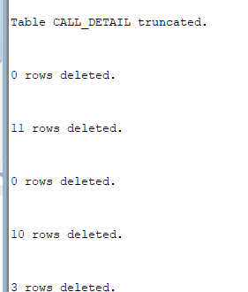

/*

CALL DATA

*/

INSERT INTO "SYSTEM"."CALL" (CALL_ID, CALL_DATETIME_START, CALL_DATETIME_END, CALL_DURATION_TIME, CALL_ORIGIN_PHONE_NUMBER, CALL_DESTINATION_PHONE_NUMBER)

VALUES ('1', TO_TIMESTAMP('2017-11-25 00:17:13.194000000', 'YYYY-MM-DD HH24:MI:SS.FF'), TO_TIMESTAMP('2017-11-29 01:17:25.139000000', 'YYYY-MM-DD HH24:MI:SS.FF'), '01:01:00', '3019996666', '3014905968');

INSERT INTO "SYSTEM"."CALL" (CALL_ID, CALL_DATETIME_START, CALL_DATETIME_END, CALL_DURATION_TIME, CALL_ORIGIN_PHONE_NUMBER, CALL_DESTINATION_PHONE_NUMBER)

VALUES ('2', TO_TIMESTAMP('2017-11-28 00:17:13.194000000', 'YYYY-MM-DD HH24:MI:SS.FF'), TO_TIMESTAMP('2017-11-28 01:17:25.139000000', 'YYYY-MM-DD HH24:MI:SS.FF'), '01:01:00', '3015556666', '3014905968');

INSERT INTO "SYSTEM"."CALL" (CALL_ID, CALL_DATETIME_START, CALL_DATETIME_END, CALL_DURATION_TIME, CALL_ORIGIN_PHONE_NUMBER, CALL_DESTINATION_PHONE_NUMBER)

VALUES ('3', TO_TIMESTAMP('2017-11-28 00:17:13.194000000', 'YYYY-MM-DD HH24:MI:SS.FF'), TO_TIMESTAMP('2017-11-28 01:17:25.139000000', 'YYYY-MM-DD HH24:MI:SS.FF'), '01:01:00', '3014446666', '3014905968');

INSERT INTO "SYSTEM"."CALL" (CALL_ID, CALL_DATETIME_START, CALL_DATETIME_END, CALL_DURATION_TIME, CALL_ORIGIN_PHONE_NUMBER, CALL_DESTINATION_PHONE_NUMBER)

VALUES ('4', TO_TIMESTAMP('2017-11-27 00:17:13.194000000', 'YYYY-MM-DD HH24:MI:SS.FF'), TO_TIMESTAMP('2017-11-27 01:17:25.139000000', 'YYYY-MM-DD HH24:MI:SS.FF'), '01:01:00', '3013336666', '3014905968');

INSERT INTO "SYSTEM"."CALL" (CALL_ID, CALL_DATETIME_START, CALL_DATETIME_END, CALL_DURATION_TIME, CALL_ORIGIN_PHONE_NUMBER, CALL_DESTINATION_PHONE_NUMBER)

VALUES ('5', TO_TIMESTAMP('2017-11-27 00:17:13.194000000', 'YYYY-MM-DD HH24:MI:SS.FF'), TO_TIMESTAMP('2017-11-27 01:17:25.139000000', 'YYYY-MM-DD HH24:MI:SS.FF'), '01:01:00', '3012226666', '3014905968');

INSERT INTO "SYSTEM"."CALL" (CALL_ID, CALL_DATETIME_START, CALL_DATETIME_END, CALL_DURATION_TIME, CALL_ORIGIN_PHONE_NUMBER, CALL_DESTINATION_PHONE_NUMBER)

VALUES ('6', TO_TIMESTAMP('2017-11-27 00:17:13.194000000', 'YYYY-MM-DD HH24:MI:SS.FF'), TO_TIMESTAMP('2017-11-27 01:17:25.139000000', 'YYYY-MM-DD HH24:MI:SS.FF'), '01:01:00', '3011116666', '3014905968');

INSERT INTO "SYSTEM"."CALL" (CALL_ID, CALL_DATETIME_START, CALL_DATETIME_END, CALL_DURATION_TIME, CALL_ORIGIN_PHONE_NUMBER, CALL_DESTINATION_PHONE_NUMBER)

VALUES ('7', TO_TIMESTAMP('2017-11-22 00:17:13.194000000', 'YYYY-MM-DD HH24:MI:SS.FF'), TO_TIMESTAMP('2017-11-22 01:17:25.139000000', 'YYYY-MM-DD HH24:MI:SS.FF'), '01:01:00', '3019995555', '3014905968');

INSERT INTO "SYSTEM"."CALL" (CALL_ID, CALL_DATETIME_START, CALL_DATETIME_END, CALL_DURATION_TIME, CALL_ORIGIN_PHONE_NUMBER, CALL_DESTINATION_PHONE_NUMBER)

VALUES ('8', TO_TIMESTAMP('2017-11-22 00:17:13.194000000', 'YYYY-MM-DD HH24:MI:SS.FF'), TO_TIMESTAMP('2017-11-22 01:17:25.139000000', 'YYYY-MM-DD HH24:MI:SS.FF'), '01:01:00', '3019994444', '3014905968');

INSERT INTO "SYSTEM"."CALL" (CALL_ID, CALL_DATETIME_START, CALL_DATETIME_END, CALL_DURATION_TIME, CALL_ORIGIN_PHONE_NUMBER, CALL_DESTINATION_PHONE_NUMBER)

VALUES ('9', TO_TIMESTAMP('2017-11-22 00:17:13.194000000', 'YYYY-MM-DD HH24:MI:SS.FF'), TO_TIMESTAMP('2017-11-22 01:17:25.139000000', 'YYYY-MM-DD HH24:MI:SS.FF'), '01:01:00', '3019993333', '3014905968');

INSERT INTO "SYSTEM"."CALL" (CALL_ID, CALL_DATETIME_START, CALL_DATETIME_END, CALL_DURATION_TIME, CALL_ORIGIN_PHONE_NUMBER, CALL_DESTINATION_PHONE_NUMBER)

VALUES ('10', TO_TIMESTAMP('2017-11-26 00:17:13.194000000', 'YYYY-MM-DD HH24:MI:SS.FF'), TO_TIMESTAMP('2017-11-26 01:17:25.139000000', 'YYYY-MM-DD HH24:MI:SS.FF'), '01:01:00', '3019921111', '3014905968');

/*

CLIENT DATA

*/

INSERT INTO "SYSTEM"."CLIENT" (CLIENT_ID, CLIENT_FIRST_NAME, CLIENT_LAST_NAME, CLIENT_PHONE_NUMBER_MOBILE) VALUES ('10', 'Joe', 'Schmo', '3019996666');

INSERT INTO "SYSTEM"."CLIENT" (CLIENT_ID, CLIENT_FIRST_NAME, CLIENT_LAST_NAME, CLIENT_PHONE_NUMBER_MOBILE) VALUES ('11', 'Mary', 'Blidge', '3015556666');

INSERT INTO "SYSTEM"."CLIENT" (CLIENT_ID, CLIENT_FIRST_NAME, CLIENT_LAST_NAME, CLIENT_PHONE_NUMBER_MOBILE) VALUES ('12', 'Ellen', 'Mazerstonson', '3014446666');

INSERT INTO "SYSTEM"."CLIENT" (CLIENT_ID, CLIENT_FIRST_NAME, CLIENT_LAST_NAME, CLIENT_PHONE_NUMBER_MOBILE) VALUES ('13', 'Steve', 'Rollerderby', '3013336666');

INSERT INTO "SYSTEM"."CLIENT" (CLIENT_ID, CLIENT_FIRST_NAME, CLIENT_LAST_NAME, CLIENT_PHONE_NUMBER_MOBILE) VALUES ('14', 'Fred', 'Fredmerkson', '3012226666');

INSERT INTO "SYSTEM"."CLIENT" (CLIENT_ID, CLIENT_FIRST_NAME, CLIENT_LAST_NAME, CLIENT_PHONE_NUMBER_MOBILE) VALUES ('15', 'Mark', 'Markerson', '3011116666');

INSERT INTO "SYSTEM"."CLIENT" (CLIENT_ID, CLIENT_FIRST_NAME, CLIENT_LAST_NAME, CLIENT_PHONE_NUMBER_MOBILE) VALUES ('16', 'William', 'Williamson', '3019995555');

INSERT INTO "SYSTEM"."CLIENT" (CLIENT_ID, CLIENT_FIRST_NAME, CLIENT_LAST_NAME, CLIENT_PHONE_NUMBER_MOBILE) VALUES ('17', 'Bobert', 'Smith', '3019994444');

INSERT INTO "SYSTEM"."CLIENT" (CLIENT_ID, CLIENT_FIRST_NAME, CLIENT_LAST_NAME, CLIENT_PHONE_NUMBER_MOBILE) VALUES ('18', 'Jack', 'Bauer', '3019993333');

INSERT INTO "SYSTEM"."CLIENT" (CLIENT_ID, CLIENT_FIRST_NAME, CLIENT_LAST_NAME, CLIENT_PHONE_NUMBER_MOBILE) VALUES ('19', 'Kelly', 'Kapinski', '3019921111');

/*

CSR DATA

Only 3 customer service representatives work for the company.

*/

INSERT INTO "SYSTEM"."CSR" (CSR_ID, CSR_FIRST_NAME, CSR_LAST_NAME, CSR_BIO, CSR_LEVEL) VALUES ('1', 'Jim', 'President', 'Jim President started Company many years ago.', '1');

INSERT INTO "SYSTEM"."CSR" (CSR_ID, CSR_FIRST_NAME, CSR_LAST_NAME, CSR_BIO, CSR_LEVEL) VALUES ('2', 'Joe', 'Sales', 'Joe Sales is the Sales Manager.', '1');

INSERT INTO "SYSTEM"."CSR" (CSR_ID, CSR_FIRST_NAME, CSR_LAST_NAME, CSR_BIO, CSR_LEVEL) VALUES ('3', 'Christie', 'Newemployee', 'Chritie Newemployee just recently started working at Company.', '2');

/*

CALL ACTION CODE DATA

*/

INSERT INTO "SYSTEM"."CALL_ACTION_CODE" (CALL_ACTION_CODE, CALL_ACTION_CODE_NAME, CALL_ACTION_CODE_TYPE, CALL_ACTION_CODE_DESCRIPTION, CALL_ACTION_CODE_PRIORITY) VALUES ('11', 'QUEUED', 'START', 'START', '1');

INSERT INTO "SYSTEM"."CALL_ACTION_CODE" (CALL_ACTION_CODE, CALL_ACTION_CODE_NAME, CALL_ACTION_CODE_TYPE, CALL_ACTION_CODE_DESCRIPTION, CALL_ACTION_CODE_PRIORITY) VALUES ('22', 'INITIATED', 'START', 'START', '1');

INSERT INTO "SYSTEM"."CALL_ACTION_CODE" (CALL_ACTION_CODE, CALL_ACTION_CODE_NAME, CALL_ACTION_CODE_TYPE, CALL_ACTION_CODE_DESCRIPTION, CALL_ACTION_CODE_PRIORITY) VALUES ('33', 'RINGING', 'START', 'START', '1');

INSERT INTO "SYSTEM"."CALL_ACTION_CODE" (CALL_ACTION_CODE, CALL_ACTION_CODE_NAME, CALL_ACTION_CODE_TYPE, CALL_ACTION_CODE_DESCRIPTION, CALL_ACTION_CODE_PRIORITY) VALUES ('44', 'ANSWERED', 'INPROGRESS', 'INPROGRESS', '2');

INSERT INTO "SYSTEM"."CALL_ACTION_CODE" (CALL_ACTION_CODE, CALL_ACTION_CODE_NAME, CALL_ACTION_CODE_TYPE, CALL_ACTION_CODE_DESCRIPTION, CALL_ACTION_CODE_PRIORITY) VALUES ('55', 'HOLDING', 'INPROGRESS', 'INPROGRESS', '2');

INSERT INTO "SYSTEM"."CALL_ACTION_CODE" (CALL_ACTION_CODE, CALL_ACTION_CODE_NAME, CALL_ACTION_CODE_TYPE, CALL_ACTION_CODE_DESCRIPTION, CALL_ACTION_CODE_PRIORITY) VALUES ('66', 'TRANSFER', 'INPROGRESS', 'INPROGRESS', '2');

INSERT INTO "SYSTEM"."CALL_ACTION_CODE" (CALL_ACTION_CODE, CALL_ACTION_CODE_NAME, CALL_ACTION_CODE_TYPE, CALL_ACTION_CODE_DESCRIPTION, CALL_ACTION_CODE_PRIORITY) VALUES ('77', 'COMPLETED', 'END', 'END', '5');

INSERT INTO "SYSTEM"."CALL_ACTION_CODE" (CALL_ACTION_CODE, CALL_ACTION_CODE_NAME, CALL_ACTION_CODE_TYPE, CALL_ACTION_CODE_DESCRIPTION, CALL_ACTION_CODE_PRIORITY) VALUES ('88', 'BUSY', 'INPROGRESS', 'INPROGRESS', '4');

INSERT INTO "SYSTEM"."CALL_ACTION_CODE" (CALL_ACTION_CODE, CALL_ACTION_CODE_NAME, CALL_ACTION_CODE_TYPE, CALL_ACTION_CODE_DESCRIPTION, CALL_ACTION_CODE_PRIORITY) VALUES ('99', 'VOICEMAIL', 'END', 'END', '4');

INSERT INTO "SYSTEM"."CALL_ACTION_CODE" (CALL_ACTION_CODE, CALL_ACTION_CODE_NAME, CALL_ACTION_CODE_TYPE, CALL_ACTION_CODE_DESCRIPTION, CALL_ACTION_CODE_PRIORITY) VALUES ('00', 'TERMINATED', 'END', 'END', '5');

INSERT INTO "SYSTEM"."CALL_ACTION_CODE" (CALL_ACTION_CODE, CALL_ACTION_CODE_NAME, CALL_ACTION_CODE_TYPE, CALL_ACTION_CODE_DESCRIPTION, CALL_ACTION_CODE_PRIORITY) VALUES ('01', 'FAILED', 'END', 'END', '5');

/*

CALL DETAIL DATA

*/

INSERT INTO "SYSTEM"."CALL_DETAIL" (CALL_DETAIL_ID, CALL_DETAIL_DESCRIPTION, CALL_CHANNEL, CALL_CALL_ID, CALL_ACTION_CODE, CLIENT_CLIENT_ID, CSR_CSR_ID) VALUES ('1', 'Client called', 'CHAN_SIP', '1', '22', '10', '3');

INSERT INTO "SYSTEM"."CALL_DETAIL" (CALL_DETAIL_ID, CALL_DETAIL_DESCRIPTION, CALL_CHANNEL, CALL_CALL_ID, CALL_ACTION_CODE, CLIENT_CLIENT_ID, CSR_CSR_ID) VALUES ('2', 'Client called', 'CHAN_SIP', '2', '22', '11', '3');

INSERT INTO "SYSTEM"."CALL_DETAIL" (CALL_DETAIL_ID, CALL_DETAIL_DESCRIPTION, CALL_CHANNEL, CALL_CALL_ID, CALL_ACTION_CODE, CLIENT_CLIENT_ID, CSR_CSR_ID) VALUES ('3', 'Client called', 'CHAN_SIP', '3', '22', '12', '3');

INSERT INTO "SYSTEM"."CALL_DETAIL" (CALL_DETAIL_ID, CALL_DETAIL_DESCRIPTION, CALL_CHANNEL, CALL_CALL_ID, CALL_ACTION_CODE, CLIENT_CLIENT_ID, CSR_CSR_ID) VALUES ('4', 'Client called', 'CHAN_SIP', '4', '22', '13', '3');

INSERT INTO "SYSTEM"."CALL_DETAIL" (CALL_DETAIL_ID, CALL_DETAIL_DESCRIPTION, CALL_CHANNEL, CALL_CALL_ID, CALL_ACTION_CODE, CLIENT_CLIENT_ID, CSR_CSR_ID) VALUES ('6', 'Client called', 'CHAN_SIP', '6', '22', '15', '2');

INSERT INTO "SYSTEM"."CALL_DETAIL" (CALL_DETAIL_ID, CALL_DETAIL_DESCRIPTION, CALL_CHANNEL, CALL_CALL_ID, CALL_ACTION_CODE, CLIENT_CLIENT_ID, CSR_CSR_ID) VALUES ('7', 'Client called', 'CHAN_SIP', '7', '22', '16', '3');

INSERT INTO "SYSTEM"."CALL_DETAIL" (CALL_DETAIL_ID, CALL_DETAIL_DESCRIPTION, CALL_CHANNEL, CALL_CALL_ID, CALL_ACTION_CODE, CLIENT_CLIENT_ID, CSR_CSR_ID) VALUES ('8', 'Client called', 'CHAN_SIP', '8', '22', '17', '3');

INSERT INTO "SYSTEM"."CALL_DETAIL" (CALL_DETAIL_ID, CALL_DETAIL_DESCRIPTION, CALL_CHANNEL, CALL_CALL_ID, CALL_ACTION_CODE, CLIENT_CLIENT_ID, CSR_CSR_ID) VALUES ('9', 'Client called', 'CHAN_SIP', '9', '22', '18', '3');

INSERT INTO "SYSTEM"."CALL_DETAIL" (CALL_DETAIL_ID, CALL_DETAIL_DESCRIPTION, CALL_CHANNEL, CALL_CALL_ID, CALL_ACTION_CODE, CLIENT_CLIENT_ID, CSR_CSR_ID) VALUES ('10', 'Client called', 'CHAN_SIP', '10', '22', '19', '3');

INSERT INTO "SYSTEM"."CALL_DETAIL" (CALL_DETAIL_ID, CALL_DETAIL_DESCRIPTION, CALL_CHANNEL, CALL_CALL_ID, CALL_ACTION_CODE, CLIENT_CLIENT_ID, CSR_CSR_ID) VALUES ('11', 'Client called', 'CHAN_SIP', '1', '77', '10', '3');

INSERT INTO "SYSTEM"."CALL_DETAIL" (CALL_DETAIL_ID, CALL_DETAIL_DESCRIPTION, CALL_CHANNEL, CALL_CALL_ID, CALL_ACTION_CODE, CLIENT_CLIENT_ID, CSR_CSR_ID) VALUES ('12', 'Client called', 'CHAN_SIP', '2', '77', '11', '3');

INSERT INTO "SYSTEM"."CALL_DETAIL" (CALL_DETAIL_ID, CALL_DETAIL_DESCRIPTION, CALL_CHANNEL, CALL_CALL_ID, CALL_ACTION_CODE, CLIENT_CLIENT_ID, CSR_CSR_ID) VALUES ('13', 'Client called', 'CHAN_SIP', '3', '77', '12', '3');

INSERT INTO "SYSTEM"."CALL_DETAIL" (CALL_DETAIL_ID, CALL_DETAIL_DESCRIPTION, CALL_CHANNEL, CALL_CALL_ID, CALL_ACTION_CODE, CLIENT_CLIENT_ID, CSR_CSR_ID) VALUES ('14', 'Client called', 'CHAN_SIP', '4', '77', '13', '3');

INSERT INTO "SYSTEM"."CALL_DETAIL" (CALL_DETAIL_ID, CALL_DETAIL_DESCRIPTION, CALL_CHANNEL, CALL_CALL_ID, CALL_ACTION_CODE, CLIENT_CLIENT_ID, CSR_CSR_ID) VALUES ('15', 'Client called', 'CHAN_SIP', '5', '99', '14', '1');

INSERT INTO "SYSTEM"."CALL_DETAIL" (CALL_DETAIL_ID, CALL_DETAIL_DESCRIPTION, CALL_CHANNEL, CALL_CALL_ID, CALL_ACTION_CODE, CLIENT_CLIENT_ID, CSR_CSR_ID) VALUES ('16', 'Client called', 'CHAN_SIP', '6', '99', '15', '2');

INSERT INTO "SYSTEM"."CALL_DETAIL" (CALL_DETAIL_ID, CALL_DETAIL_DESCRIPTION, CALL_CHANNEL, CALL_CALL_ID, CALL_ACTION_CODE, CLIENT_CLIENT_ID, CSR_CSR_ID) VALUES ('17', 'Client called', 'CHAN_SIP', '7', '77', '16', '3');

INSERT INTO "SYSTEM"."CALL_DETAIL" (CALL_DETAIL_ID, CALL_DETAIL_DESCRIPTION, CALL_CHANNEL, CALL_CALL_ID, CALL_ACTION_CODE, CLIENT_CLIENT_ID, CSR_CSR_ID) VALUES ('18', 'Client called', 'CHAN_SIP', '8', '77', '17', '3');

INSERT INTO "SYSTEM"."CALL_DETAIL" (CALL_DETAIL_ID, CALL_DETAIL_DESCRIPTION, CALL_CHANNEL, CALL_CALL_ID, CALL_ACTION_CODE, CLIENT_CLIENT_ID, CSR_CSR_ID) VALUES ('19', 'Client called', 'CHAN_SIP', '9', '77', '18', '3');

INSERT INTO "SYSTEM"."CALL_DETAIL" (CALL_DETAIL_ID, CALL_DETAIL_DESCRIPTION, CALL_CHANNEL, CALL_CALL_ID, CALL_ACTION_CODE, CLIENT_CLIENT_ID, CSR_CSR_ID) VALUES ('20', 'Client called', 'CHAN_SIP', '10', '77', '19', '3');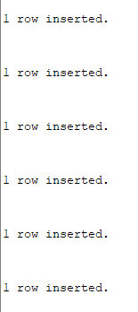

--Select all columns and all rows from one table.

SELECT * FROM CALL;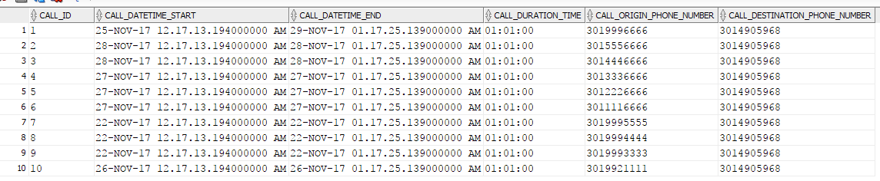

--Select 5 columns and all rows from one table.

SELECT CALL_ID, CALL_DATETIME_START, CALL_DATETIME_END, CALL_DURATION_TIME, CALL_ORIGIN_PHONE_NUMBER FROM CALL;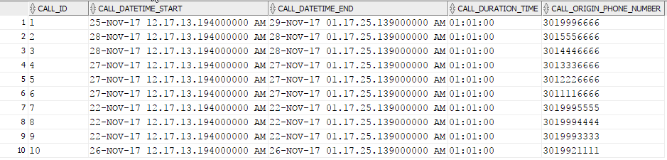

--Select all columns and all rows from one view.

SELECT * FROM CLIENTS;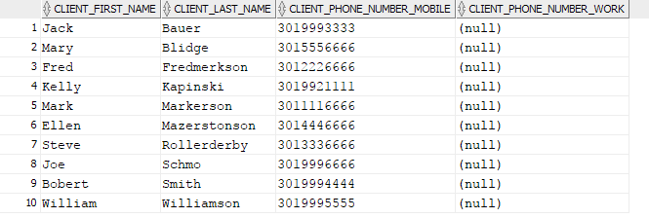

--Using a join on 2 tables, select all columns and all rows from the tables without the use of a Cartesian product.

SELECT

CALL.*,

CLIENT.*

FROM CALL

JOIN CLIENT ON CALL.CALL_ORIGIN_PHONE_NUMBER = CLIENT.CLIENT_PHONE_NUMBER_MOBILE

WHERE CLIENT_ID = 10;

--Select and order data retrieved from one table.

SELECT * FROM CALL

ORDER BY CALL_DATETIME_START;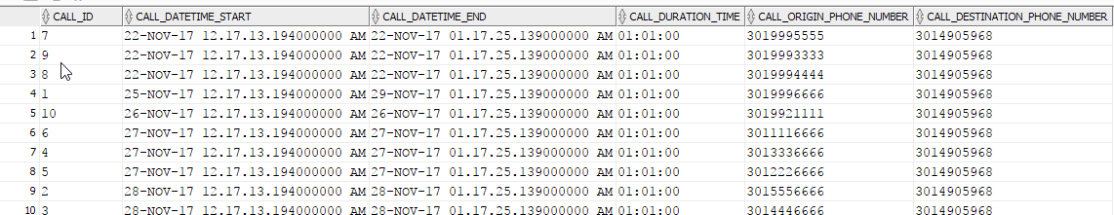

--Using a join on 3 tables, select 5 columns from the 3 tables. Use syntax that would limit the output to 10 rows.

SELECT * FROM

(

SELECT

CALL.CALL_ID,

CALL.CALL_DURATION_TIME,

CALL_DETAIL.CALL_DETAIL_DESCRIPTION,

CLIENT.CLIENT_LAST_NAME,

CALL_ACTION_CODE.CALL_ACTION_CODE_NAME

FROM CALL

JOIN CALL_DETAIL ON CALL.CALL_ID = CALL_DETAIL.CALL_CALL_ID

JOIN CLIENT ON CALL.CALL_ORIGIN_PHONE_NUMBER = CLIENT.CLIENT_PHONE_NUMBER_MOBILE

JOIN CALL_ACTION_CODE ON CALL_ACTION_CODE.CALL_ACTION_CODE = CALL_DETAIL.CALL_ACTION_CODE

ORDER BY CALL_DURATION_TIME

)

WHERE ROWNUM <= 5;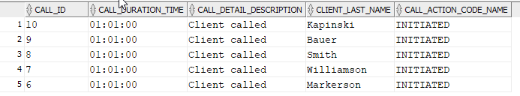

--Select distinct rows using joins on 3 tables.

SELECT DISTINCT

CALL.CALL_DURATION_TIME

FROM CALL

JOIN CALL_DETAIL ON CALL.CALL_ID = CALL_DETAIL.CALL_CALL_ID

JOIN CLIENT ON CALL.CALL_ORIGIN_PHONE_NUMBER = CLIENT.CLIENT_PHONE_NUMBER_MOBILE

JOIN CALL_ACTION_CODE ON CALL_ACTION_CODE.CALL_ACTION_CODE = CALL_DETAIL.CALL_ACTION_CODE;

--Use GROUP BY & HAVING in a select statement using one or more tables.

SELECT CSR_LEVEL AS "Max Assigned CSR Level"

FROM CSR

GROUP BY CSR_LEVEL

HAVING MAX(CSR_LEVEL) = 1;



--Use IN clause to select data from one or more tables.

SELECT * FROM CALL_ACTION_CODE

WHERE CALL_ACTION_CODE_TYPE

IN ('START');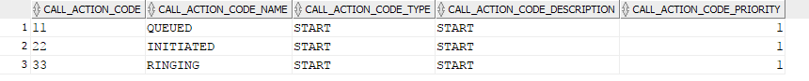

--Select length of one column from one table (use LENGTH function).

SELECT DISTINCT LENGTH(CALL_DETAIL_DESCRIPTION) FROM CALL_DETAIL;

--Use the SQL DELETE statement to delete one record from one table. Add select statements to demonstrate the table contents before and after the DELETE statement. Make sure to use ROLLBACK afterwards so that the data will not be physically removed.

SELECT * FROM CALL_DETAIL;

DELETE FROM CALL_DETAIL WHERE CALL_CALL_ID = 1;

SELECT * FROM CALL_DETAIL;

ROLLBACK;

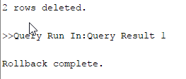

--Use the SQL UPDATE statement to change some data. Add select statements to demonstrate the table contents before and after the UPDATE statement. You can either COMMIT or ROLLBACK afterwards.

SELECT * FROM CALL_DETAIL WHERE CALL_DETAIL_ID = 1;

UPDATE CALL_DETAIL

SET CALL_DETAIL_DESCRIPTION = 'No description'

WHERE CALL_DETAIL_ID = 1;

SELECT * FROM CALL_DETAIL WHERE CALL_DETAIL_ID = 1;

ROLLBACK;

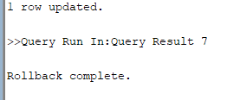

--Using Coronel, Morris and Rob’s definition of Advanced SQL (Chapter 8), perform 8 additional advanced (multiple table joins, sub-queries, aggregate, etc.) SQL statements.

--1 USE A UNION TO GET CALL IDS

SELECT CALL.CALL_ID FROM CALL

UNION

SELECT CALL_DETAIL.CALL_CALL_ID FROM CALL_DETAIL;

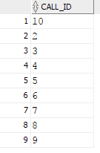

--2 USE A UNION ALL TO GET CALL IDS

SELECT CALL.CALL_ID FROM CALL

UNION ALL

SELECT CALL_DETAIL.CALL_CALL_ID FROM CALL_DETAIL;

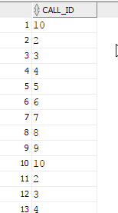

--USING 3 JOINS DETERMINE THE CALL INFORMATION

SELECT

CALL.*,

CALL_DETAIL.*,

CLIENT.*,

CALL_ACTION_CODE.*

FROM CALL

INNER JOIN CALL_DETAIL ON CALL.CALL_ID = CALL_DETAIL.CALL_CALL_ID

INNER JOIN CLIENT ON CALL.CALL_ORIGIN_PHONE_NUMBER = CLIENT.CLIENT_PHONE_NUMBER_MOBILE

INNER JOIN CALL_ACTION_CODE ON CALL_DETAIL.CALL_ACTION_CODE = CALL_ACTION_CODE.CALL_ACTION_CODE;

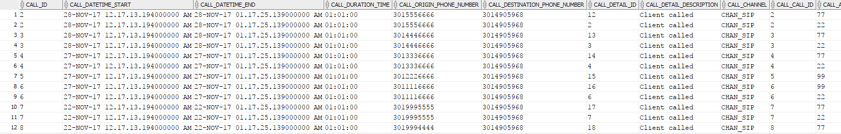

--4 DETERMINE THE MIN CALL ACTION CODE PRIORITY USING AGGREGATE FUNCTION

SELECT MIN(CALL_ACTION_CODE.CALL_ACTION_CODE_PRIORITY)

FROM CALL_ACTION_CODE;



--5 DETERMINE WHAT ACTION CODES HAVE BEEN USED

SELECT CALL_ACTION_CODE.CALL_ACTION_CODE

FROM CALL_ACTION_CODE

WHERE CALL_ACTION_CODE

IN (

SELECT CALL_DETAIL.CALL_ACTION_CODE FROM CALL_DETAIL

);

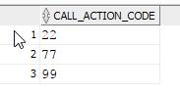

--6 DETERMINE THE FIRST AND LAST NAME OF THE CUSTOMER FOR ALL CUSTOMER SUPPORT ISSUES ESCALATED

SELECT DISTINCT(C.CLIENT_ID), C.CLIENT_FIRST_NAME, C.CLIENT_LAST_NAME

FROM CLIENT C

JOIN CALL_DETAIL D ON C.CLIENT_ID = D.CLIENT_CLIENT_ID

JOIN CSR S ON S.CSR_ID = D.CSR_CSR_ID

WHERE S.CSR_LEVEL < 2;

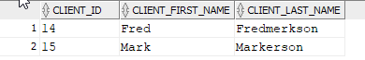

--7 FIND ALL AREA CODE 301 CALLS

SELECT * FROM CALL

WHERE CALL_ORIGIN_PHONE_NUMBER LIKE '301%%%%%%%';

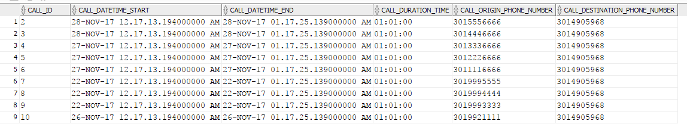

--8 FIND UNUSUALLY LATE CALLS

SELECT CALL.CALL_ID, TO_CHAR(CALL_DATETIME_START, 'hh24:mi:ss') AS "CALL START", TO_CHAR(CALL_DATETIME_END, 'hh24:mi:ss') AS "CALL END"

FROM CALL

WHERE TO_CHAR(CALL_DATETIME_START, 'hh24:mi:ss') BETWEEN '00:%%:%%' AND '05:%%:%%'

AND TO_CHAR(CALL_DATETIME_END, 'hh24:mi:ss') BETWEEN '00:%%:%%' AND '05:%%:%%';

